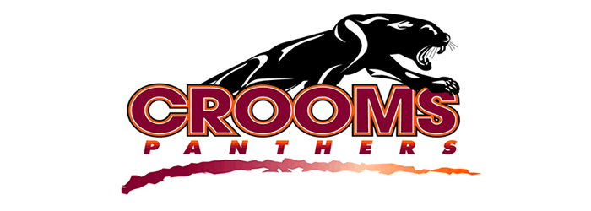
Bowling 2018 SCHEDULE
DATE | OPPONENT | TIME | LOCATION
Aug. 20 (Monday) | Lake Brantley | 3:00 | Oviedo
Aug. 22 (Wed) | Bye | 3:00 | Airport
Aug. 27 (Mon) | Winter Springs | 3:00 | Oviedo
Aug. 29 (Wed) | Oviedo | 3:00 | Altamonte
Sept. 4 (Tues) | Seminole | 3:00 | Airport
Sept. 5 (Wed) | Lake Mary | 3:00 | Oviedo
Sept. 10 (Monday) | Lake Howell | 3:00 | Airport
Sept. 12 (Wed) | Lyman | 3:00 | Altamonte
Sept. 17 (Mon) | Hagerty | 3:00 | Oviedo
Sept. 19 (Wed) | Lake Brantley | 3:00 | Airport
Sept. 24 (Mon) | Bye | 3:00 | Oviedo
Sept. 26 (Wed) | Winter Springs | 3:00 | Airport
Oct. 1 (Mon) | Oviedo | 3:00 | Oviedo
Oct. 3 (Wed) | Seminole | 3:00 | Altamonte
Oct. 8 (Mon) | Lake Mary | 3:00 | Airport
Oct. 10 (Wed) | Lake Howell | 3:00 | Oviedo
Oct. 15 (Monday) | Lyman | 3:00 | Airport
Oct. 17 (Wed.) | Hagerty | 3:00 | Altamonte

GIRLS HEAD COACH: CATHY ALPER
BOYS HEAD COACH: WALTER SESSIONS
ATHLETIC DIRECTOR: DR. MILLER
PRINCIPAL: DR. HANSHAW

